FRONTEND SETUP
1. FIRST we have the folder ready – final frontend
2. go to the api.js file in the files
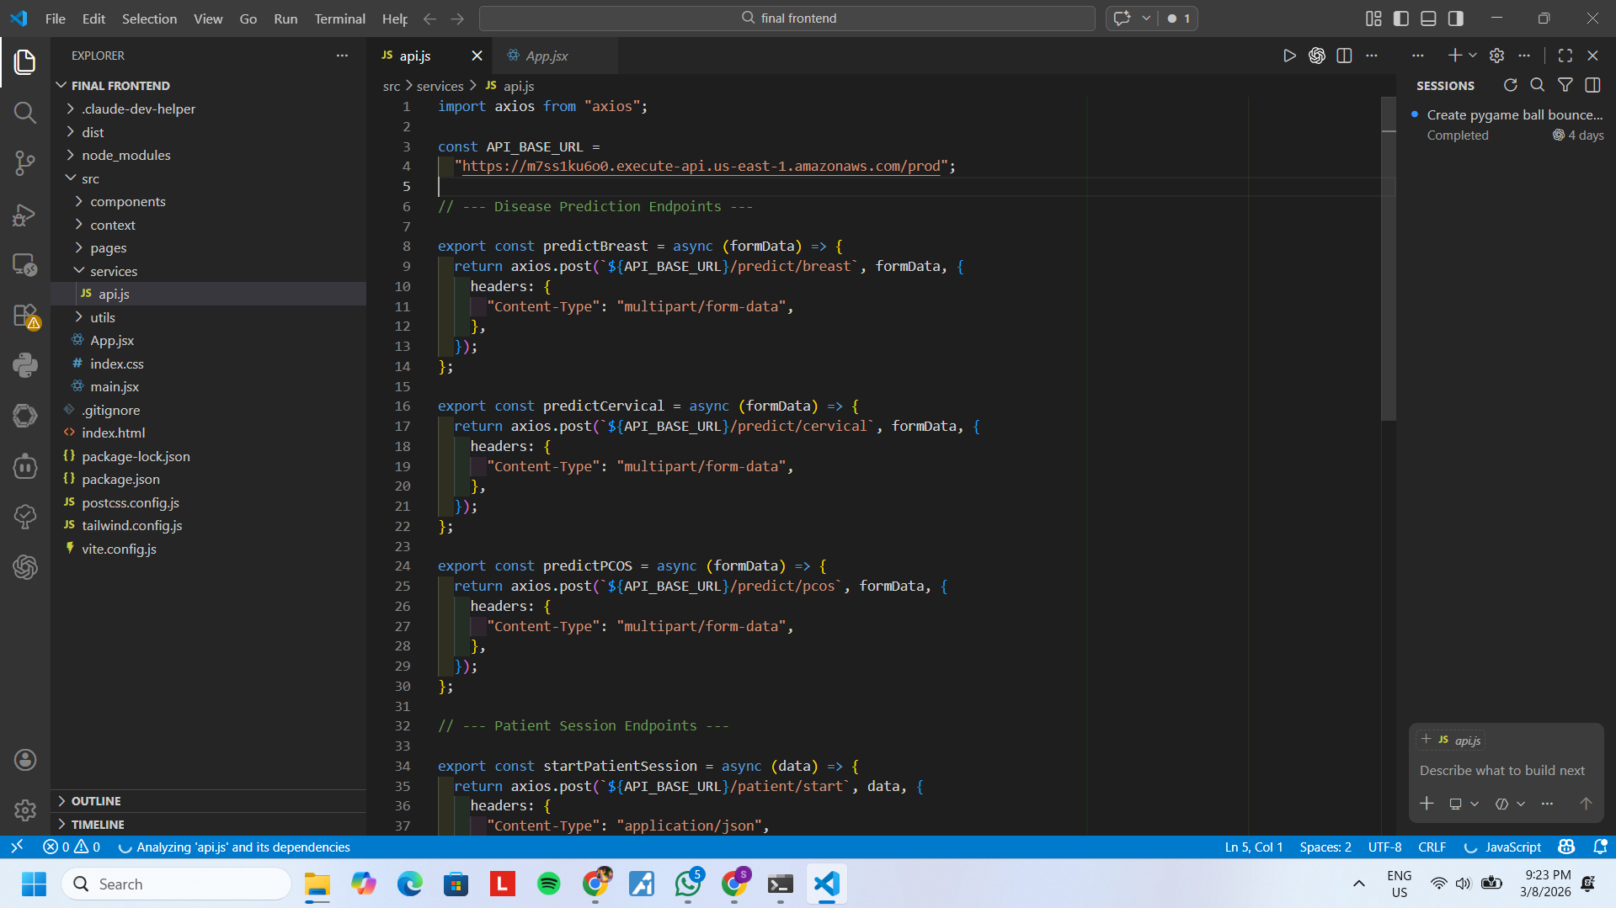
3. in the constant api base url – put the url from the api name stages part
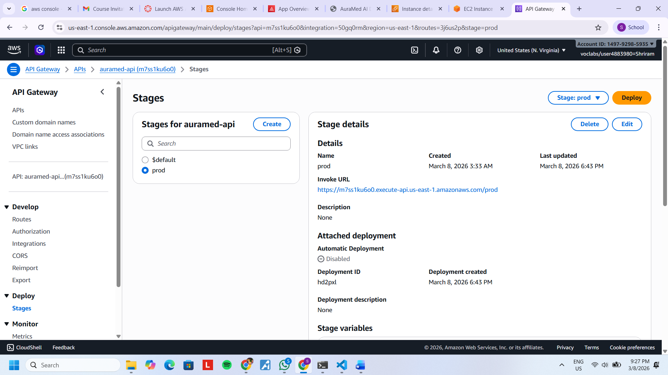
And use that in the place in api.js
4. then create the amplify by giving github to the frontend folder created, automatically site will open

